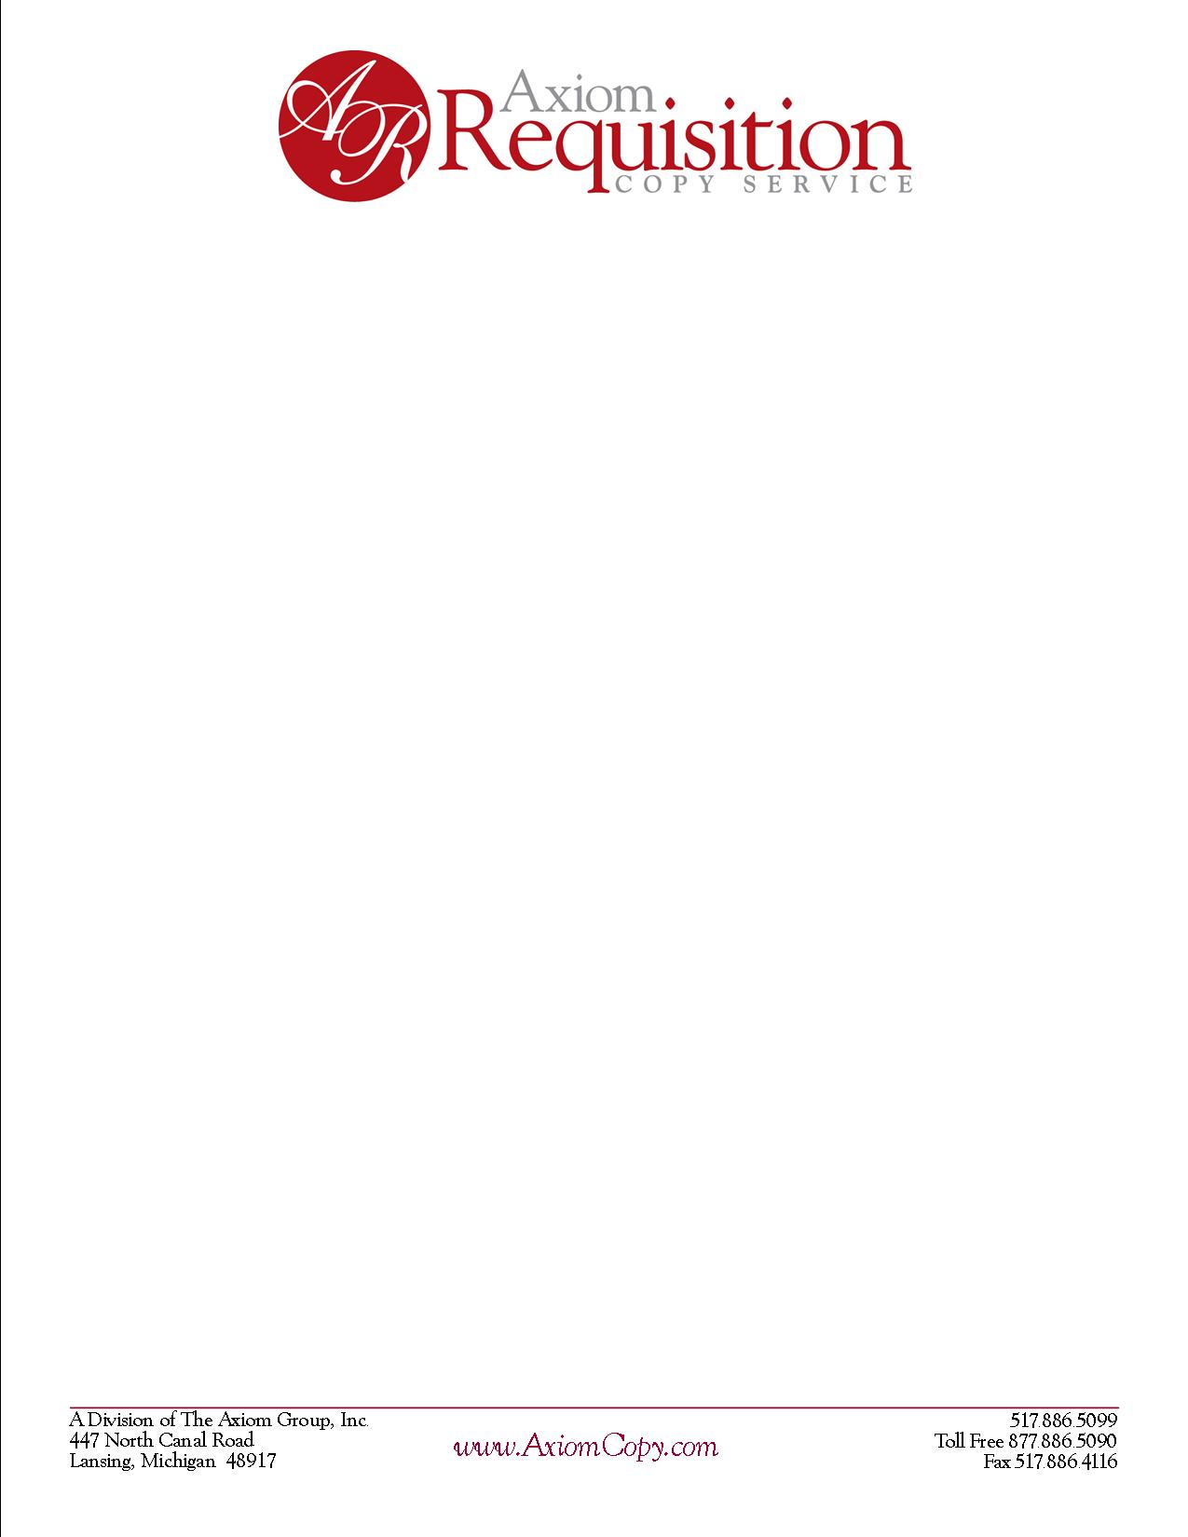

**June 18, 2014**

## TO THE CUSTODIAN OF RECORDS

**Straith Hospital Dr. Lanny Green**

**Dept. Medical Records**

**23901 Lahser Rd**

**Southfield, MI 48034-3296**

RE: **Merlene Beasley**

**DOB 10/07/1941** **SSN XXX-XX-1928**

Dear Custodian of records,

We are in receipt of the records for the above-mentioned individual.

**THIS IS NOT ANOTHER REQUEST FOR RECORDS.** However, per the Texas Judicial System we are required to have the attached Direct Interrogatory Questions answered pertaining to the billing records that you have provided to us pertaining to the above patient

If you should have any questions regarding this matter, please do not hesitate to contact me.

Thank you for your assistance in this matter.

**Luke Remwolt**

**Account Executive**

**ORDER NUMBER 01-31017-015**

|  |  |  |
| --- | --- | --- |
| A Division of The Axiom Group Inc.  2869 Jolly Road  Okemos, MI 48864 | *www.AxiomCopy.com* | 517.886.5099  Toll Free 877.886.5090  Fax 517.925.5165 |